Internet Programming
Lab experiment 2
Aim
To develop a responsive online hotel room booking website that allows users to search, check availability, book, modify, and cancel hotel rooms, while enabling administrators to manage rooms, prices, bookings, users, and website information.
Algorithm
- Start the hotel booking website.
- Register/login as User or Administrator.
- Users search for hotels using destination, dates, and number of guests.
- Display available rooms with price, amenities, and reviews.
- User selects a room and checks availability.
- Enter booking details and complete payment.
- Generate booking confirmation and allow users to view booking history.
- Allow modification or cancellation up to 3 days before arrival.
- Administrator manages room quantity, prices, bookings, users, and static pages.
10. Display contact, FAQ, travel guide, and privacy policy.
11.End.
Program:
<!DOCTYPE html>
<html lang="en">
<head>
<meta charset="UTF-8">
<meta name="viewport" content="width=device-width, initial-scale=1.0">
<title>StayEase Hotel Booking</title>
<style>
body{font-family:Arial;margin:0;background:#f4f7fa;color:#333}
header{background:#173b57;color:white;padding:18px;display:flex;
justify-content:space-between;align-items:center;flex-wrap:wrap}
.logo{font-size:25px;font-weight:bold}
nav a,nav button{color:white;margin:6px;text-decoration:none}
button{background:#087f8c;color:white;border:0;padding:10px;
border-radius:5px;cursor:pointer}
input,select{padding:10px;margin:6px;border:1px solid #ccc;
border-radius:5px;max-width:90%}
.hero{text-align:center;padding:65px 15px;background:#d9edf2}
.hero h1{font-size:36px;color:#173b57}
.section{text-align:center;padding:30px 15px}
.rooms{display:flex;justify-content:center;gap:20px;flex-wrap:wrap}
.room{background:white;padding:20px;width:220px;border-radius:10px;
box-shadow:0 2px 8px #ccc}
.room h3{color:#087f8c}
.light{background:#eaf1f5}
.modal{display:none;position:fixed;inset:0;background:#0009;
justify-content:center;align-items:center;padding:10px}
.content{background:white;padding:25px;border-radius:10px;
width:320px;max-width:90%;max-height:85vh;overflow:auto}
.content input,.content select{display:block;width:90%}
.close{float:right;cursor:pointer;font-size:24px}
footer{text-align:center;background:#173b57;color:white;padding:15px}
</style>
</head>
<body>

<header>
<div class="logo">StayEase</div>
<nav>
<a href="#home">Home</a>
<a href="#rooms">Rooms</a>
<a href="#about">About</a>
<button onclick="show('login')">Login</button>
<button onclick="show('register')">Register</button>
<button onclick="show('admin')">Admin</button>
</nav>
</header>

<section class="hero" id="home">
<h1>Find Your Perfect Stay</h1>
<p>Comfortable rooms at the best prices</p>
<input id="destination" placeholder="Destination">
<input type="date" id="checkin">
<input type="date" id="checkout">
<input type="number" id="guests" min="1" value="1">
<button onclick="searchRooms()">Search Rooms</button>
</section>

<section class="section" id="rooms">
<h2>Available Rooms</h2>
<div class="rooms" id="roomContainer"></div>
</section>

<section class="section light" id="about">
<h2>About Us</h2>
<p>StayEase helps customers find rooms, compare prices
and manage hotel bookings easily.</p>
</section>

<section class="section">
<h2>Contact Us</h2>
<p>Email: support@stayease.com</p>
<p>Phone: +91 98765 43210</p>
<p>Chennai, Tamil Nadu, India</p>
</section>

<section class="section light">
<h2>Frequently Asked Questions</h2>
<p>Can I cancel? Yes, up to 3 days before arrival.</p>
<p>Can I modify my booking? Yes, up to 3 days before arrival.</p>
</section>

<footer>© 2026 StayEase Hotel Booking System</footer>

<!-- Login -->
<div class="modal" id="login">
<div class="content">
<span class="close" onclick="hideAll()">×</span>
<h2>User Login</h2>
<input id="loginEmail" type="email" placeholder="Email">
<input id="loginPass" type="password" placeholder="Password">
<button onclick="loginUser()">Login</button>
</div></div>

<!-- Registration -->
<div class="modal" id="register">
<div class="content">
<span class="close" onclick="hideAll()">×</span>
<h2>Create Account</h2>
<input id="regName" placeholder="Full Name">
<input id="regEmail" type="email" placeholder="Email">
<input id="regPass" type="password" placeholder="Password">
<button onclick="registerUser()">Register</button>
</div></div>

<!-- Booking -->
<div class="modal" id="booking">
<div class="content">
<span class="close" onclick="hideAll()">×</span>
<h2>Book Room</h2>
<input id="bookName" placeholder="Full Name">
<input id="bookEmail" type="email" placeholder="Email">
<input id="bookRoom" readonly>
<input id="bookDate" type="date">
<button onclick="confirmBooking()">Confirm Booking</button>
</div></div>

<!-- Admin -->
<div class="modal" id="admin">
<div class="content">
<span class="close" onclick="hideAll()">×</span>
<h2>Admin Panel</h2>
<input id="adminUser" placeholder="Username">
<input id="adminPass" type="password" placeholder="Password">
<button onclick="adminLogin()">Admin Login</button>
<div id="adminPanel" style="display:none">
<h3>Manage Rooms</h3>
<select id="roomType">
<option>Deluxe</option><option>Suite</option>
<option>Standard</option><option>Family</option>
</select>
<input id="roomPrice" type="number" placeholder="Price">
<input id="roomQty" type="number" placeholder="Quantity">
<button onclick="updateRoom()">Update Room</button>
<h3>Bookings</h3>
<div id="bookingList"></div>
</div></div></div>

<script>
let rooms=[
{name:"Standard",price:1500,qty:5},
{name:"Deluxe",price:2500,qty:4},
{name:"Suite",price:4000,qty:2},
{name:"Family",price:3500,qty:3}
];
let bookings=[];
let users=[];

function show(id){
document.getElementById(id).style.display="flex";
}
function hideAll(){
document.querySelectorAll(".modal").forEach(m=>m.style.display="none");
}
function displayRooms(list=rooms){
let c=document.getElementById("roomContainer");
c.innerHTML="";
list.forEach(r=>{
c.innerHTML+=`<div class="room">
<h3>${r.name} Room</h3>
<p>Price: ₹${r.price} / night</p>
<p>Available: ${r.qty}</p>
<button onclick="book('${r.name}')"
${r.qty<1?"disabled":""}>Book Now</button>
</div>`;
});
}
function searchRooms(){
let d=document.getElementById("destination").value;
let a=document.getElementById("checkin").value;
let b=document.getElementById("checkout").value;
if(!d||!a||!b){alert("Enter destination and dates");return;}
if(b<=a){alert("Checkout must be after check-in");return;}
displayRooms();
document.getElementById("rooms").scrollIntoView();
}
function registerUser(){
let n=regName.value,e=regEmail.value,p=regPass.value;
if(!n||!e||!p){alert("Fill all fields");return;}
if(users.some(u=>u.email===e)){alert("Email already registered");return;}
users.push({name:n,email:e,password:p});
alert("Registration successful");hideAll();
}
function loginUser(){
let u=users.find(u=>u.email===loginEmail.value&&
u.password===loginPass.value);
if(u){alert("Welcome "+u.name);hideAll();}
else alert("Invalid login. Please register first.");
}
function book(name){
bookRoom.value=name;
bookDate.min=checkin.value||new Date().toISOString().slice(0,10);
bookDate.value=checkin.value||bookDate.min;
show("booking");
}
function confirmBooking(){
let n=bookName.value,e=bookEmail.value,d=bookDate.value;
let r=rooms.find(r=>r.name===bookRoom.value);
if(!n||!e||!d){alert("Fill all booking details");return;}
if(d<new Date().toISOString().slice(0,10)){
alert("Select a valid date");return;
}
if(!r||r.qty<1){alert("Room unavailable");return;}
bookings.push({name:n,email:e,room:r.name,date:d});
r.qty--;
alert("Booking confirmed!");
hideAll();displayRooms();showBookings();
}
function adminLogin(){
if(adminUser.value==="admin"&&adminPass.value==="admin123"){
adminPanel.style.display="block";
showBookings();
}else alert("Invalid admin credentials");
}
function updateRoom(){
let r=rooms.find(r=>r.name===roomType.value);
let p=Number(roomPrice.value),q=Number(roomQty.value);
if(roomPrice.value===""||roomQty.value===""||p<0||q<0){
alert("Enter valid price and quantity");return;
}
r.price=p;r.qty=q;
displayRooms();alert("Room details updated");
}
function showBookings(){
bookingList.innerHTML=bookings.length?
bookings.map(b=>`<p>${b.name} - ${b.room} - ${b.date}</p>`).join("")
:"No bookings yet.";
}
displayRooms();
</script>
</body>
</html>
Output:
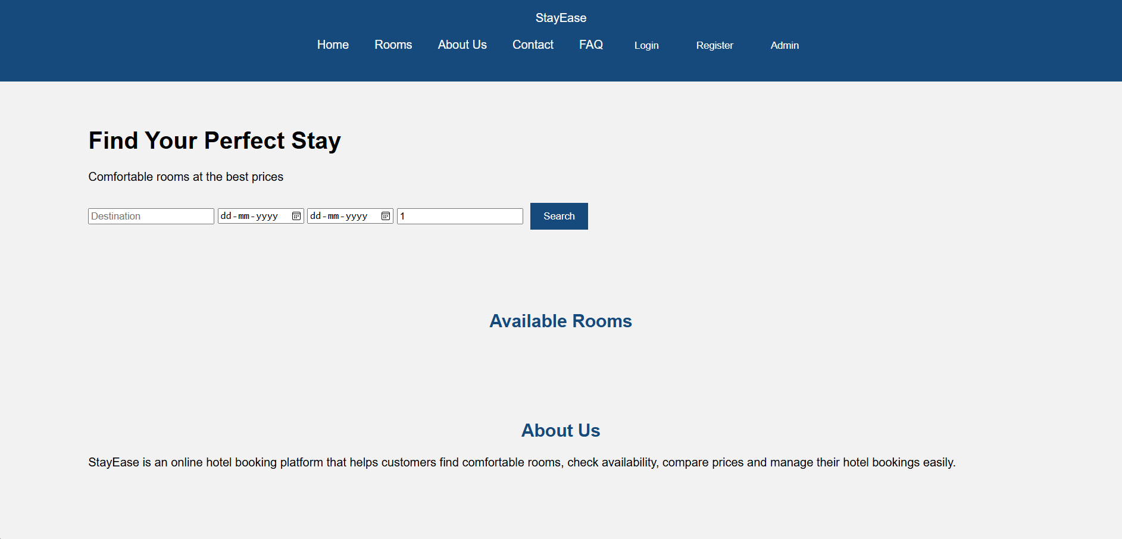
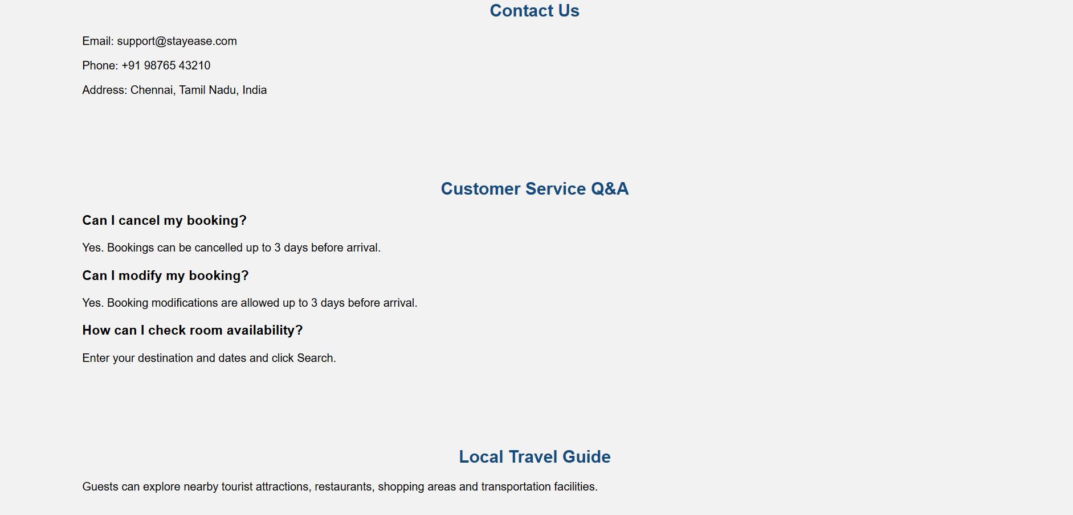
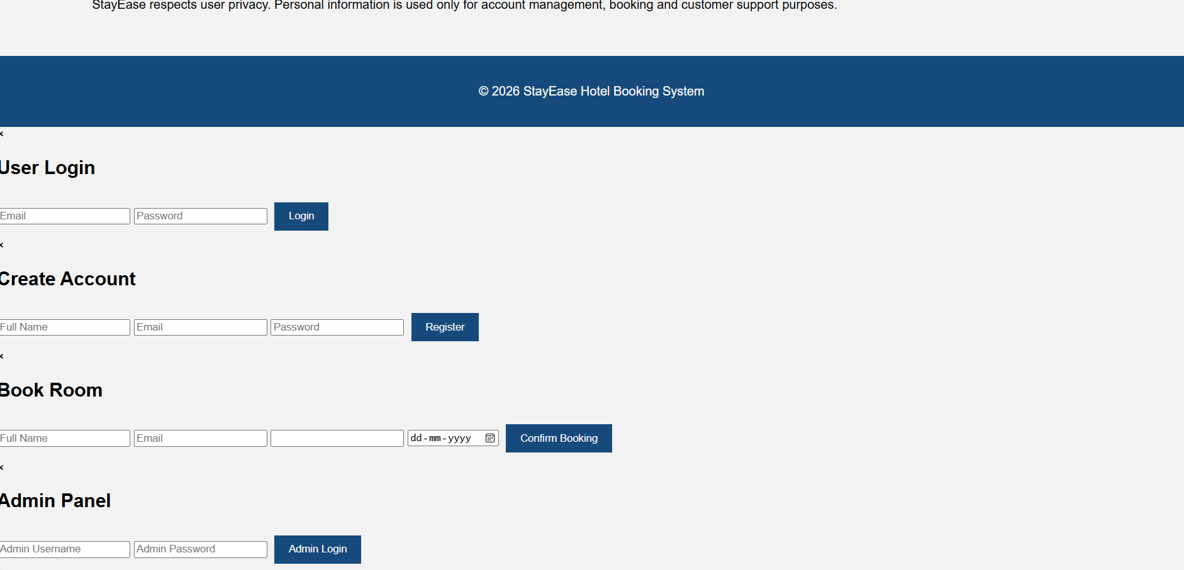
Result
The online hotel room booking website was successfully designed to provide convenient room searching, availability checking, booking, payment, and booking management for users, along with complete administrative control over rooms, prices, bookings, and website information.

